PROJECT REPORT

PROJECT TITLE : Car Resale value Prediction

TEAM ID : PNT2022TMID26206

TEAM MEMBERS : KIRRAN P L (Team Leader)

KAMALANADHAN M

KATHIRVEL A

HARISH S

1.INTRODUCTION

1.1 PROJECT OVERVIEW

The Car Valuation Tool is a free tool designed to help you get the estimated resale value of your car within seconds.Our automobile valuation algorithm is real-time updated, so it keeps up with the most recent modifications and market trends. However, the amounts displayed during the online assessment are only estimates and might alter when the retailer inspects your automobile. You don't even need to register to have your automobile valued; all you need to do is provide some basic information about it, such as its make, model, amount of miles driven, city of residence, and contact information.

1.2 Purpose

In 2019, the Indian used automobile resale industry was valued at $24.2 billion USD. There is a critical need to close this gap between sellers and buyers due to the enormous demand for used automobiles and the shortage of professionals who can evaluate the proper valuation. The goal of this research is to create a system that can impartially forecast a car's resale value based on little information such as the number of miles travelled and the year of purchase.The process of determining the current used automobile pricing in a certain location is known as used car value. By selecting the brand, model, year, trim, and the number of kilometers travelled, a user of OBV may quickly determine the used car's price. The value of a used automobile is based on a number of variables, including its state right now, when it was bought, etc. Used automobile valuation will never have a precise price; instead, it will always fall within a reasonable price range.

2. LITERATURE SURVEY

2.1 Existing Problem

Car Resale value prediction is one of the best to sell our in this market for an best and better price. Rather than giving our car to an less price , the customer those who uses the car will be benifitted and the seller will also be benefitted.The goal of this research is to create a system that can impartially forecast a car's resale value based on little information such as the number of miles travelled and the year of purchase. You don't even need to register to have your automobile valued; all you need to do is provide some basic information about it, such as its make, model, amount of miles driven, city of residence, and contact information.

2.2 References

1. Pudaruth Sameerchand , Pudaruth Sameerchand , Predicting the price of Used Car Using Machine Learning Techniques
2. Enis gegic, Becir ,Isakovic, Dino Keco, ,Zerina Masetic,Jasmin Kevric Car Price Prediction Using Machine Learning
3. Ning sun,Hongxi Bai,Yuxia Geng,Huizhu Shi Price Evaluation model in second hand car system
4. Doan Van Thai, Luong Ngoc Son, Pham Vu Tien, Nguyen Nhat Anh, Nguyen Thi Ngoc Anh Prediction car prices using qualify qualitative data and knowledge-based system

2.3 Problem Statement Definition

Car Resale value prediction is used to predict the value of the used cars to an reasonable price which satisfies the customer.

3. IDEATION AND PROPOSED SOLUTION

3.1 Empathy Map Canvas

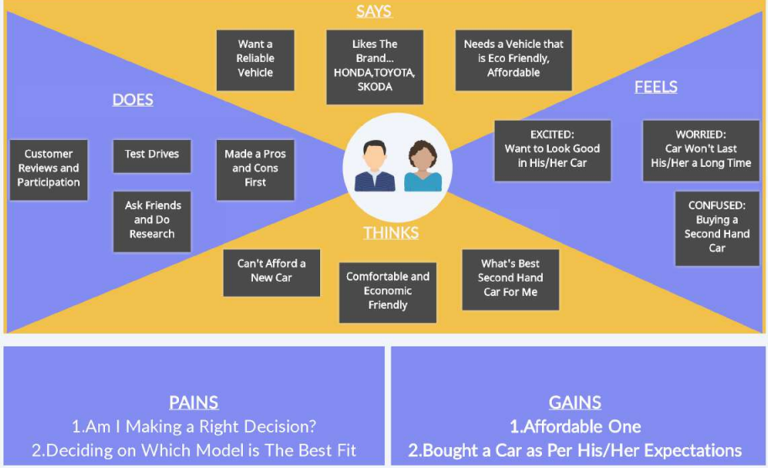

**3.2 Propose Solution**

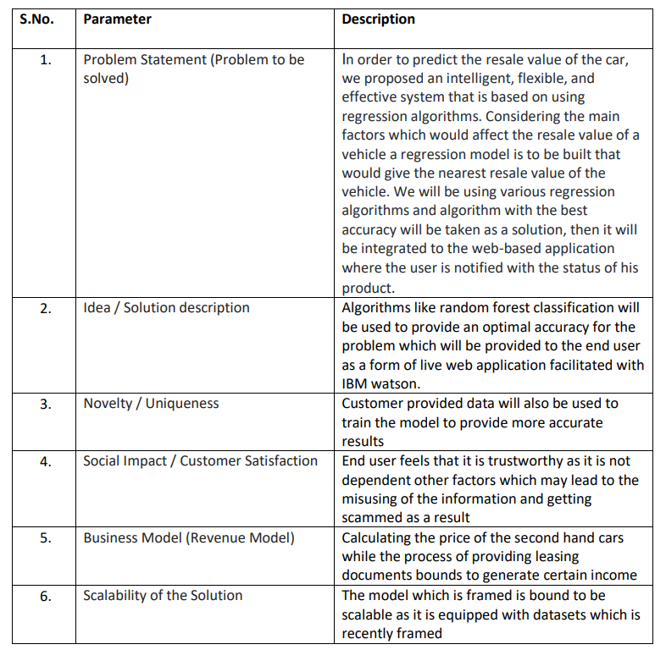

**3.4 Problem Solution Fit**

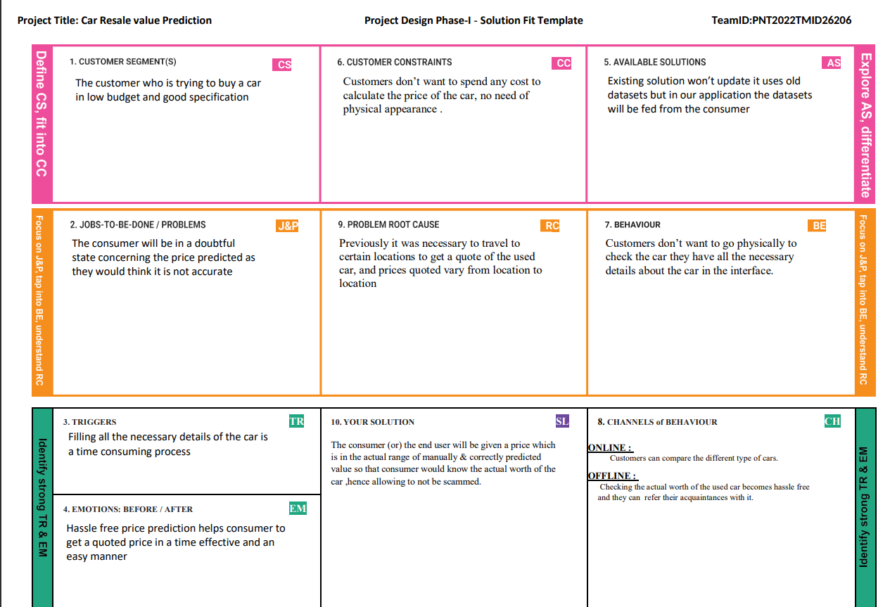

**4.REQUIREMENT ANALYSIS**

**4.1 Functional Requirements:**

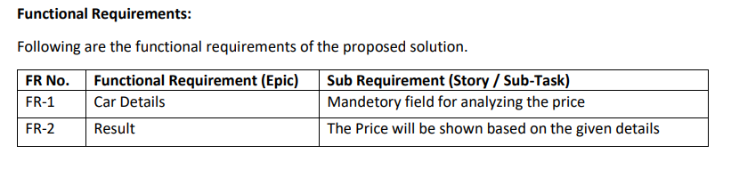

**4.2 Non Functional Requirements:**

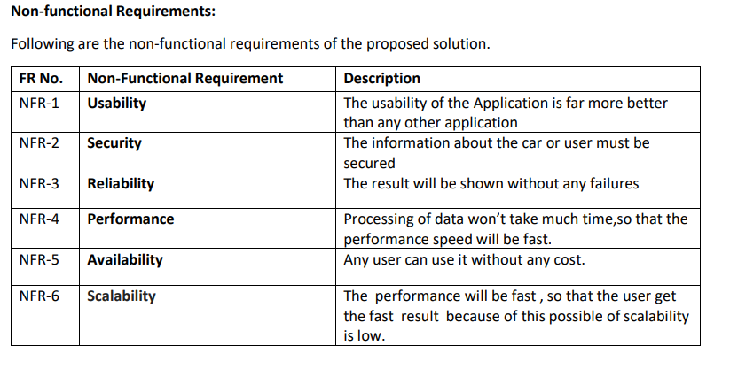

**5. PROJECT DESIGN**

**5.1 Data Flow Diagram**

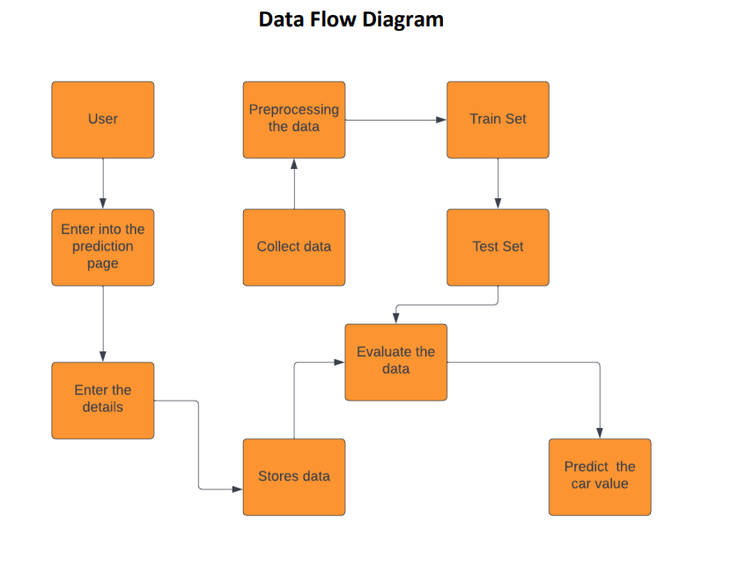

**5.2 Solution Architecture**

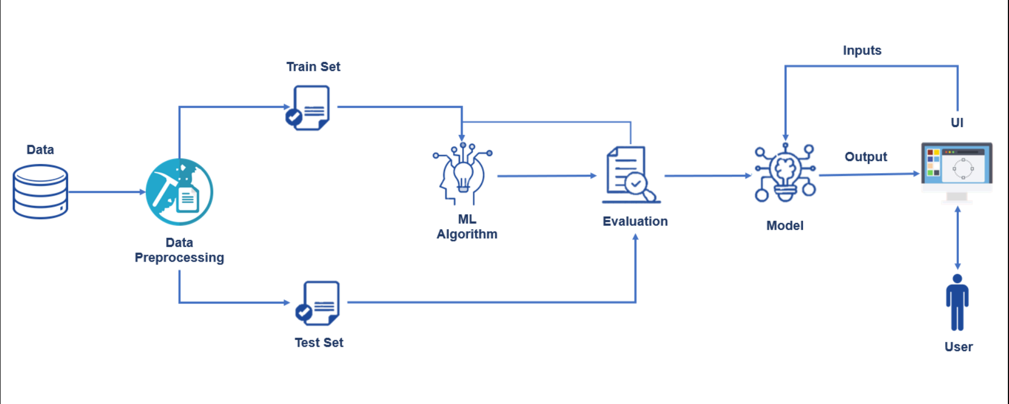

**5.3 User Stories**

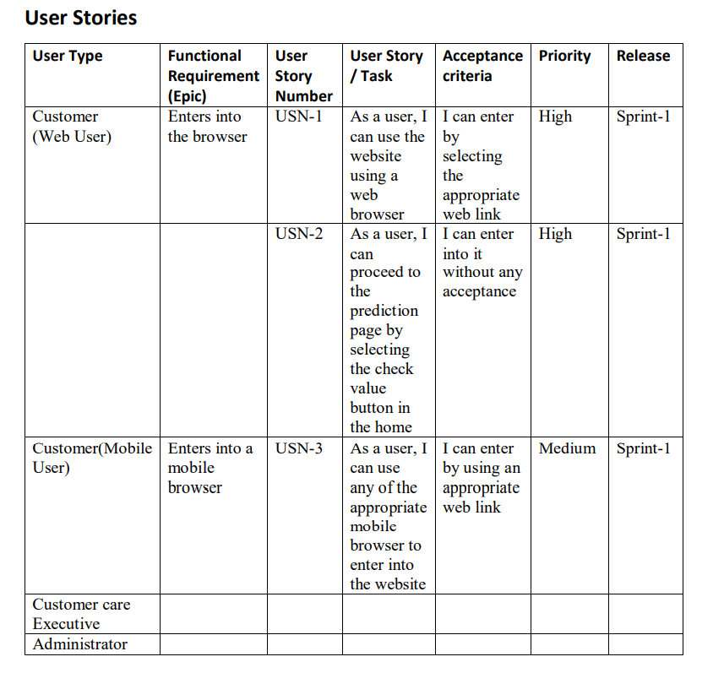

**6. PROJECT PLANNING & SCHEDULING**

**6.1 Sprint Planning & Estimation**

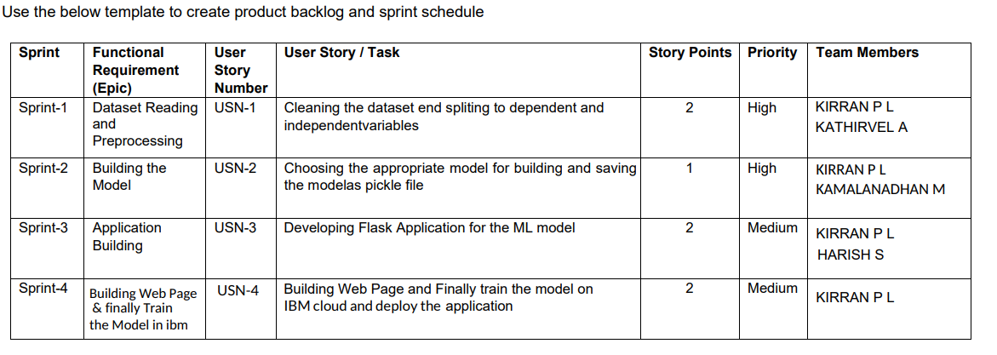

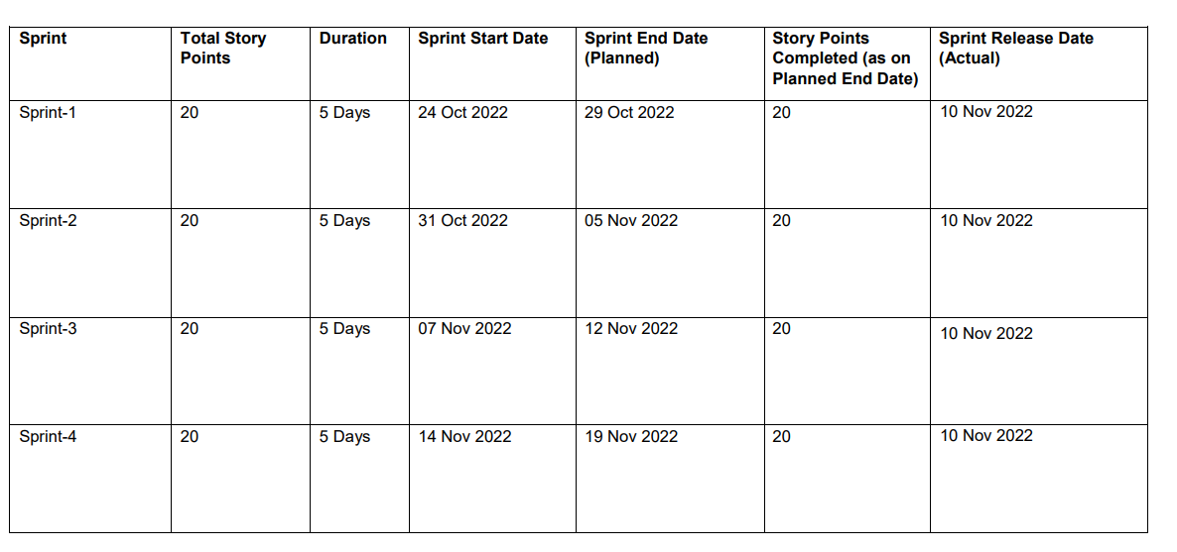

**7.CODING & SOLUTIONING**

**Features:**

* **IBM Watson Studio**
* **Web UI**
* **Python Code**
* **Flask**
* **Machine Learning**

**8.TESTING And RESULTS:**

